EXPERIMENT 7

* Write a CPU bound C program and a I/O bound C program and observe the effect of their CPU share using the top command and its variants.
* CPU-BOUND-MATRIX

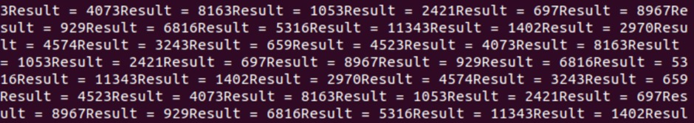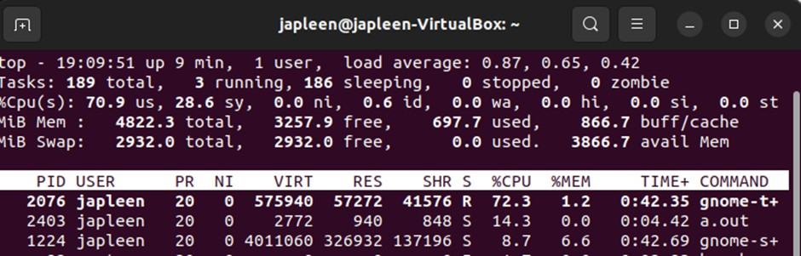

* CPU-BOUND-PRIME

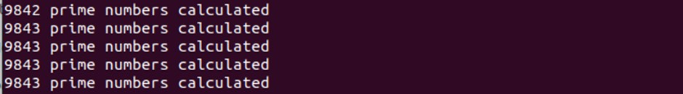

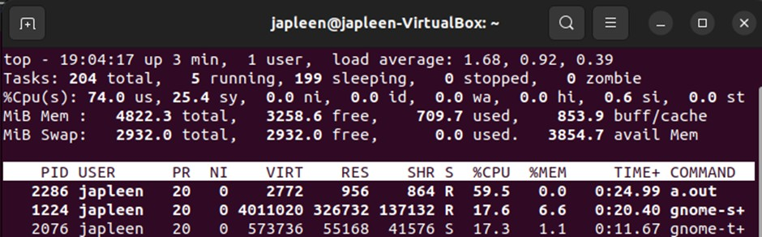

* IO BOUND

